CENWP-OD-WI March 17, 2017

MEMORANDUM FOR THE RECORD: 17 IHR 002 – MFR UPDATED South shore AWS pumps turned off due to high tailwater. Updated March 21, 2017.

SUBJECT: Ice Harbor AWS pumps turned off to prevent flooding of the warehouse

At approximately 1415 hours on March 16, all of the south shore auxiliary water supply (AWS) pumps at Ice Harbor were shut off, due to tailwater elevations exceeding 353'. This was done to prevent flooding of the warehouse inside the dam, per Section IHR 2.4.2 of the 2017 Fish Passage Plan (FPP). It was thought the pumps would likely remain out of service until at least March 20, as river flows at Ice Harbor are expected to peak for the next several days. The AWS pumps were returned to service March 17 at 1314 hrs when tailwater dropped below 353’. Initially, project maintenance staff were planning on working today to change the operation of the south fish ladder (close floating orifices, raise entrance weir gates, etc.) as needed to meet the criteria outlined for AWS pump failure in Section IHR 3.3.2.4 of the FPP. (A photo of one of the operating floating orifices at the south end of the powerhouse and the adjacent south shore tailwater staff gauge are shown below). However, upon consideration of the logistics of closing

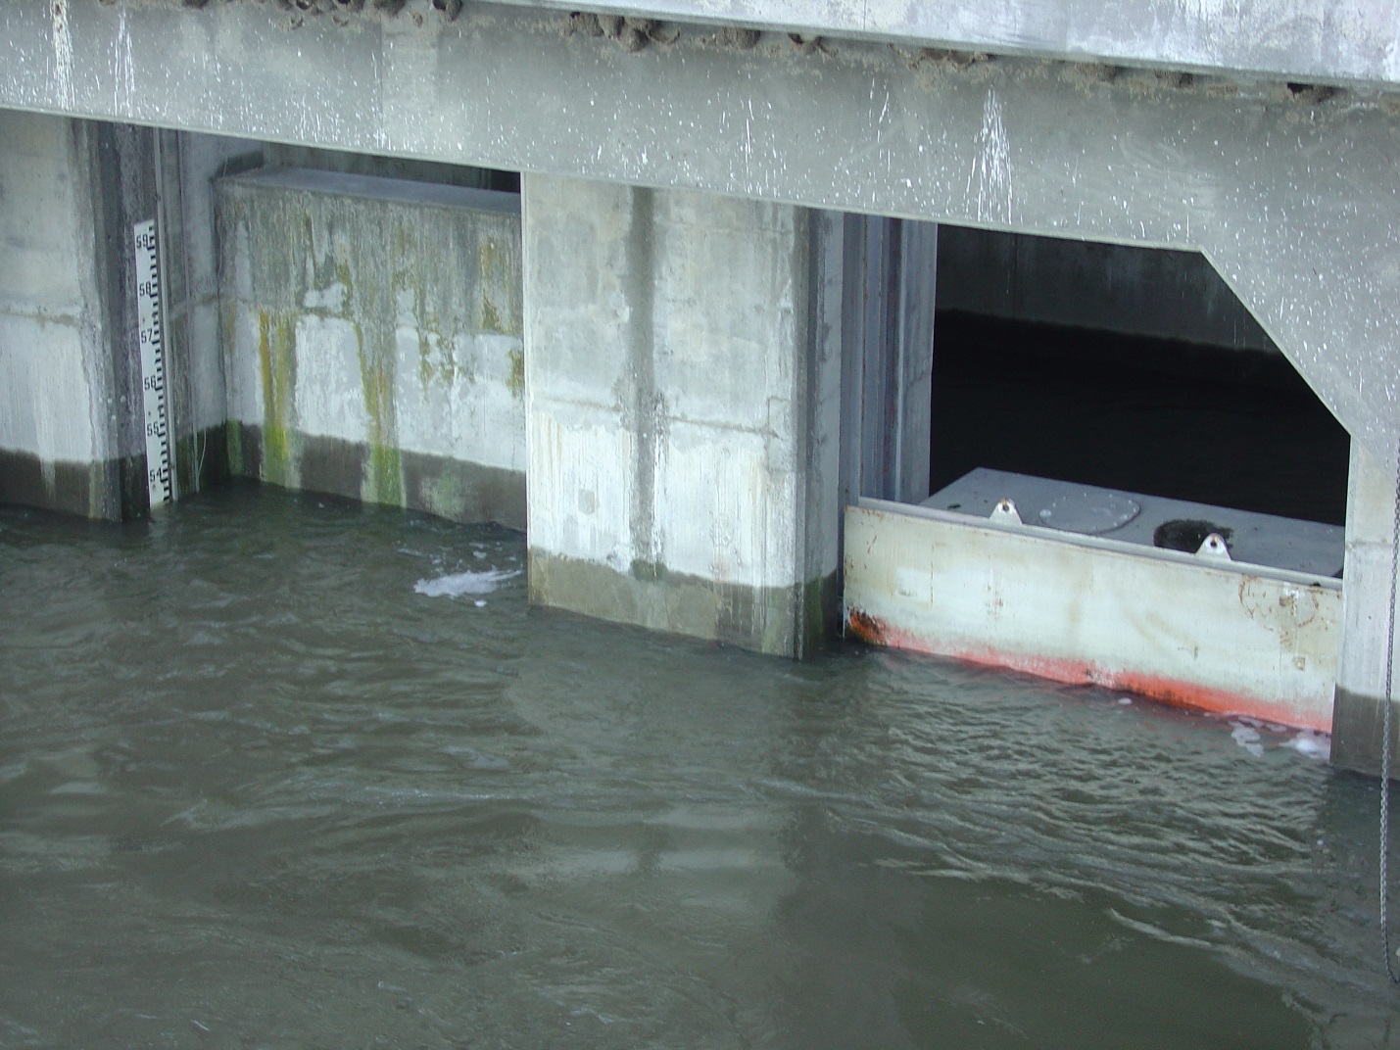
Figure 1. IHR operating floating orifice, sometimes referred to as a FOG (floating orifice gate).
off the floating orifices with the high tailwater, project staff realized that they only have enough spare stop logs to close off one floating orifice. Also, as of this morning, tailwater elevations are about even with the top of stop logs of closed floating orifices (approximately 353.6’), as shown in the photo below. So the steps outlined in Sections 3.3.2.4.b and 3.3.2.4.c cannot be accomplished with current high tailwater conditions.

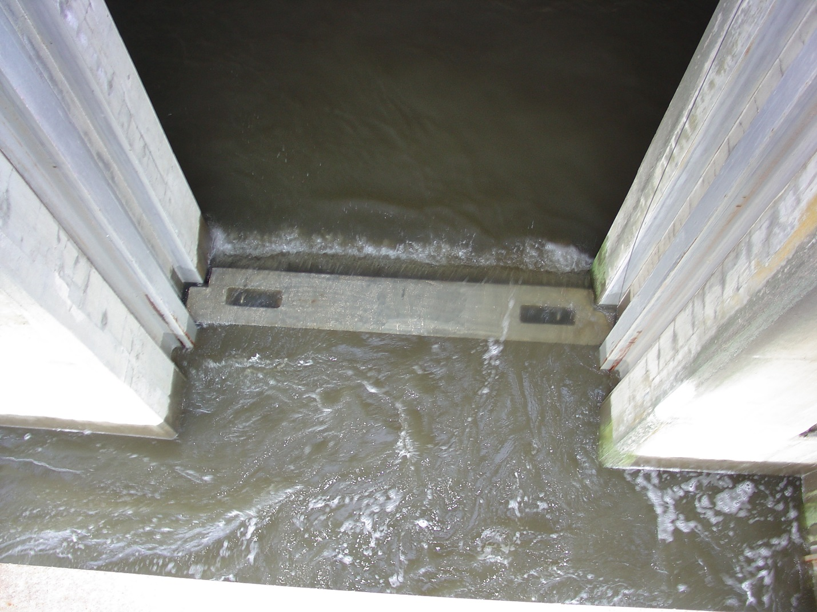
Figure 2. Tailrace overtopping closed floating orifice at Ice Harbor Dam.

Section 3.3.2.4.d calls for the north powerhouse entrance weir gate (NFE-2) be closed and the adult fish channel be bulkheaded off at the junction pool, leaving only the south shore entrance (SSE-1) in operation. With high tailwater conditions and no south shore AWS pumps in service, the south shore tailwater level is approximately 0.5’ higher than the south shore channel level, so water is flowing into SSE-1. As shown in the photo below, tailwater is also flowing into the fish ladder over the top of the adjacent closed SSE-2 weir gate, which is raised to its maximum height. Gravity flow of approximately 142 cfs is coming down the ladder from the ladder exit and upper diffuser. During normal operation, six south shore AWS pumps supply an additional 1,800 cfs to the bottom of the fish ladder to meet the channel/tailwater differential criteria of 1-2’. Walla Walla District hydrologists and the Hydrology & Hydraulics Branch Chief were consulted. Closure of the north powerhouse entrance weir gate (NFE-2) and bulkheading the adult fish channel would not be sufficient to negate the -0.5 channel/tailwater differential nor provide sufficient flow through the entrance to bring the adult fishway entrance into criteria without the south shore auxiliary water supply pumps.

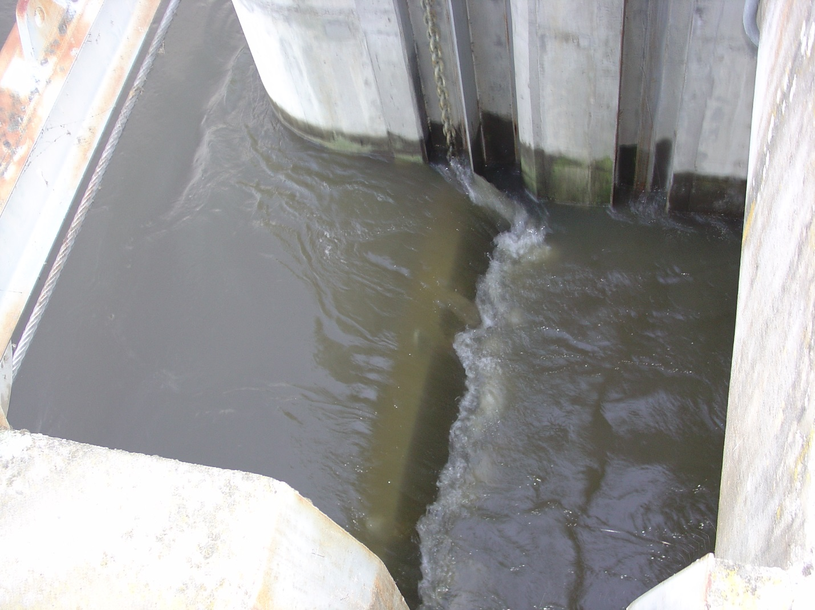
Figure 3. Tailrace overtopping closed fishway entrance SSE2 at Ice Harbor Dam.

Consequently, the project will not be carrying out the steps outlined in Section 3.3.2.4. During the period that the south shore AWS pumps are off, the south fish ladder will be out of FPP operating criteria. The north shore fish ladder is operating normally and meeting FPP criteria.

Ken Fone
Ice Harbor Project
Fisheries Biologist

